# Rafael Javier Mayoral González

# Jorge Navarro García

# Computer

## Uses GPS

The web page requires to use your GPS service to calculate the idiom that you could understand and on the top of the page you can select the most appropriate that you want.

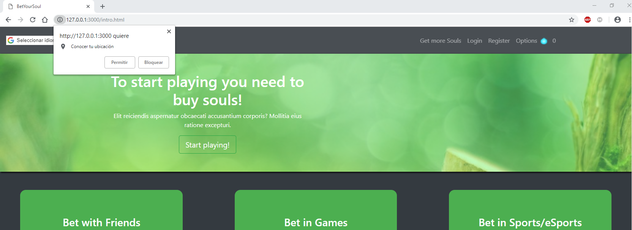

## Touch Screen

We implement a script with functions that permit and android, IOS, Blackberry or Windows phone can open the web application without problems and charge all the pictures, style documents and java scripts.

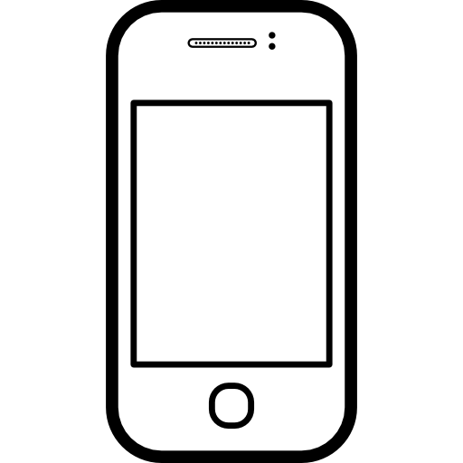

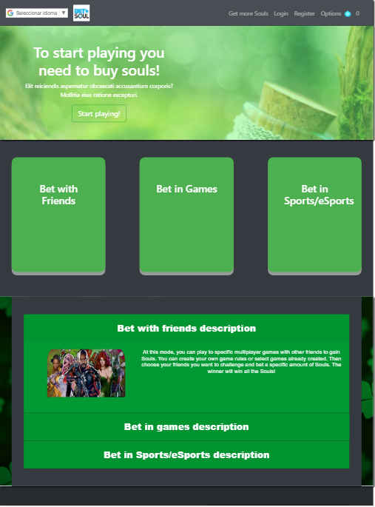

## Uses access to Internet

This is a very important requirements and very simple in a computer, but a mobile can use another browser, for example in iPhone uses Safari or Samsung has his own browser called Samsung Internet, so we implement other scripts to can use the web applications with the another different browser if you do not have Chrome or Firefox.

## Our application uses as programming language Javascript, Html and CSS

We have used HTML5 to develop the web app and CSS good styles and improve the user interface. Although, we have used Javascript to run some scripts in the web app.

## The app uses virtual coins to run

To be able to use some aspects of the web app we need to have Souls in our profile. We can obtain Souls with real money in the statement Get More Souls.

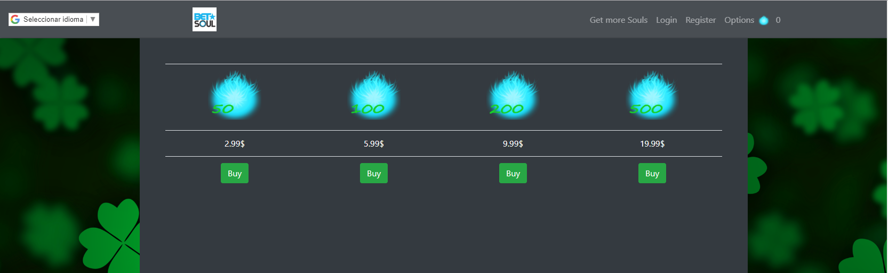

# Interaction

## Dialogue with the user

We implement some feedback at the end of the page to can “talk” with the user by emails to continue improve the web page with fix some bugs that the users detect or suggestions.

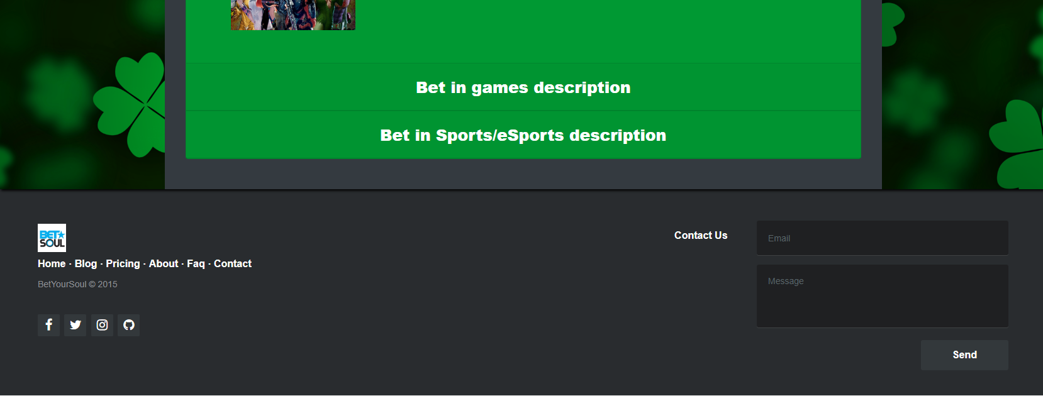

## Menus and windows

We implement alerts or pop-ups that communicate with the user which simulate that the web page said something or warned you of something. For example, when you spin the roulette, before it, we can see an alert that said *Good Luck!*

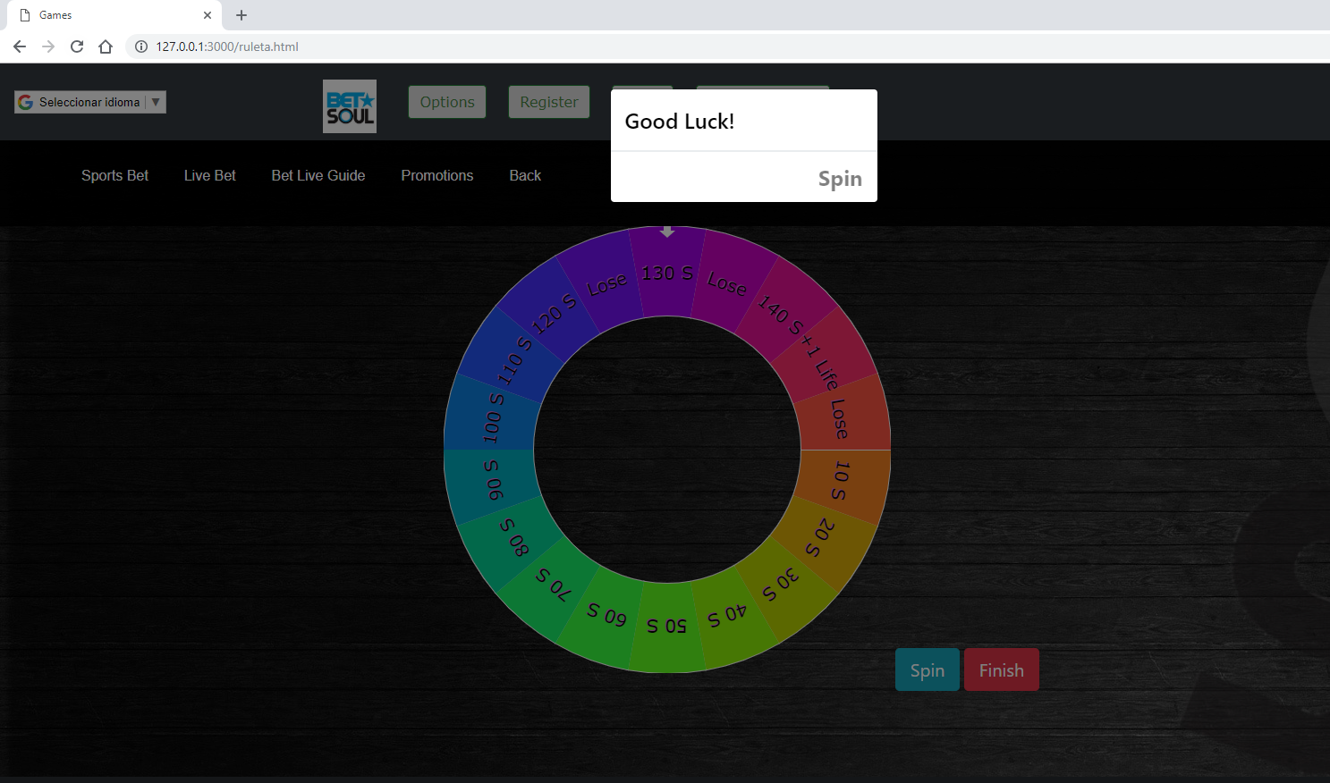

## Real-time actuation with the game

In our web app we have added games in which you can interact in real-time, for example a roulette of prizes in which we obtain Souls or Lifes as prizes.

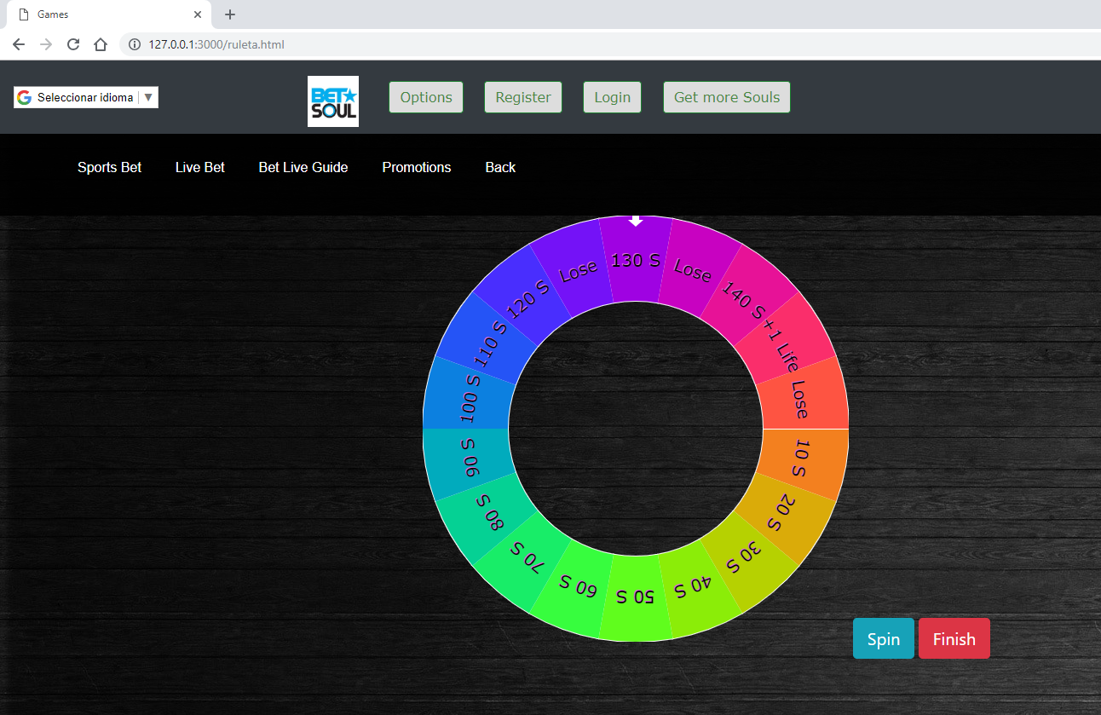

## Two players interaction game

Finally, we supported the possibility to play with another user in the web app by adding a tic-tac toe game that is divided in turns and each user’s clicks on a cell to try tic-tac toe.

